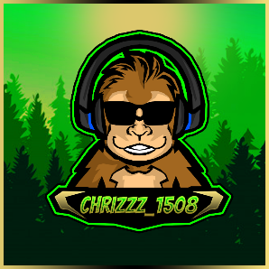Pokemon and Friends Mod (SAMMI)

Created By: chrizzz_1508

Version: 1.2

___________________________________________________________________________________________

Table of contents

Description 3

Patchnotes: 3

V1.0: 3

V1.1: 4

V1.2: 4

Requirements 5

OBS 5

SAMMI 5

Other 5

Fresh Installation 6

Important notes about the installation 6

Creating a discord webhook (optional) 6

1. Deleting the existing Stuff 6

2. Install the OBS Plugins 7

3. Install / Configure SAMMI 8

4. Install the PaF Game 11

Upgrading from V1.1.6 or lower 15

Functions 16

Spawn Mechanic 16

Runaway Mechanic 16

Catch Mechanic 16

Broadcaster Commands 17

Mod Commands 17

Viewer Commands 18

Channel Point Rewards 19

Changing Settings 20

Potential Fixes 21

General: 21

Discord webhook not working: 21

Gifs not showing: 21

Profile Pictures not working in the Catch Screenshot / Game keeps crashing on throws 22

Special Thanks to some awesome People 23

Final notes 23

Support me 24

# Description

This mod is based on the classic Pokemon and Friends Game for LB1 from the StreamUP Team.

# Patchnotes:

V1.0:

- HD graphics / GIF’s (a few GIFs are missing or have bad quality)

- Support for all 905 Pokémon + regional forms (+53) (Normal & Shiny)

- **Pokeball**, **Greatball**, **Ultraball** and **Masterball** as separate channel point rewards

- **Mystery Pokemon** / **Mystery Shiny, Summon Pokemon** Channel Point Rewards to summon a Pokémons

- **Give a Gift** Channel Point Reward to reduce the current runaway rate

- New Commands ( **!catchrate**, **!escaperate**, **!mypokemon (en/de/fr)**, **!top10 / !top10shiny**, **!rank**, **!summon *, !summonshiny \***, **!poke-stop**, **!bonustime**, **!trainers**, **!settrainer** )

- Change of the spawn & runaway mechanic

- Customizable loading screen / loading animation / loading sound when a new Pokémon spawns

- Customizable Shiny wallpapers

- Discord webhook to post / check the caught Pokémon

- Automatic refund if a player already caught a Pokémon

- Multi language support (German, English and French)

- Priority Catch (If someone summons a Pokémon, they gets a free random ball)

- Bonus time (Raids & Hosts boost the spawn-, catch- and shiny rate for X min)

- Queue system to give slower viewers a fair chance

- Pokémon Trainer feature (Viewers can set their own custom trainer avatar)

- Automatic Backup of the Trainer.ini

- For the first time, this also supports a Non-Affiliate version that works with chat commands instead of channel points

- **Settings all in one place!** Change the game to best suit your channel!

V1.1:

- Mythical / Legendarys spawn much rarer and can be announced in chat

- Added Animated trainers

- New commands ( **!pet \***, **!poke-filter**, **!poke-filter \*** )

- Databases enhanced for incoming PvP and custom Pokémon Add On

- Spawn Selection for each Generation (for example Gen 1 and Gen 3 only)

- Added Shiny symbol on discord screenshot

- Added Spanish, Italian and reworked French Language Keys

- Show Pokémon Infos on LB2 stream deck (and full stream deck support)

- Bot account support

- Added a “Check for Update” function on startup

- Moved loading animation to an extra scene

- Ignore upper / lowercase for Pokémon names

- Some minor bugfixes

V1.2:

- Added Mega & Custom Pokémon

- New commands **(!namechange**, **!sendpokemon**, **!sendshiny**, **!addpokemon**, **!addshiny**, **!top10likeability**)

- Changed Database to CSV files (way faster now)

- Added a possible Catchrate increase through the PvP AddOn

- Added an OBS Plugin Installer

- Added a CSV converter

- Switch everything over to SAMMI from LB2

- Added an option to change the ball queue time

- Changed some commands and background processes (Reworked 26+ Buttons)

- Added a check to prevent Pokémon from spawning while the old one is still despawning

# Requirements

In order to install this project, you must have the following software installed properly. Please refer to the installation guide/steps that are provided by the creators of the software.

OBS

[OBS Studio](https://obsproject.com/) V27 (V28 is not recommended but also works, but only with OBSWS 4.9.1)

SAMMI

[SAMMI V2022.4.1+](https://github.com/SAMMISolutions/SAMMI-Official/releases)

Other

[Maximum of 42 Channel Point Rewards](https://link.twitch.tv/myChannelPoints) (this app needs to be able to create up to 8 new rewards)

[.NetFramework 4.8](https://go.microsoft.com/fwlink/?linkid=2088631)

[Pokémon Font](https://drive.google.com/uc?export=download&id=1oNlm5WDVYA46RIc_jIRsq_F2FvQmjfs4)¹

¹ Install the font while OBS is closed. If you install fonts while OBS is open it won't recognize it until you re-launch OBS.

# Fresh Installation

## **Important notes about the installation**

Do NOT create Channel Points rewards yourself in Twitch, these rewards are created  
automatically in the installation process.  
If this doesn't work, try deleting the existing ones and run the **!poke-install** command again.

Feel free to customize the color, picture, description, and even the reward cost.

The name can only be adjusted in the Mod Installer before creating the channel points. If you want to change it later, you will have to adjust the triggers in the “**Pokemon and Friends Mod**” Deck as well.

## **Creating a discord webhook (optional)**

To create a discord webhook you need to go to your discord “***Server Settings***” 🡺 “***Integrations***” 🡺 “***Webhooks***” 🡺 “***Create a new webhook***” 🡺 And make sure to “***Save***” the webhook URL.

*This is necessary if you would like the game to automatically post your viewer’s Pokémon catches in Discord and the “***!mypokemon***” command to work properly.*

## **Deleting the existing Stuff**

* 1. If you have used a Version lower than V1.1.6 delete all existing Pokémon and Friends scenes from OBS
  2. Delete all existing Channel Point Rewards
  3. Remove LB1 / LB2 from OBS (delete the Dock / Browser source)

## **Install the OBS Plugins**

* 1. Make sure that OBS is closed
  2. Start the **PaF SAMMI Mod Installer**

If the installer won’t start because it’s getting recognized as a security threat, this has to do with it being not signed. In that case you might have to manually allow it to be run. To do this, first click “***More Info***” and then “***Run anyway***”

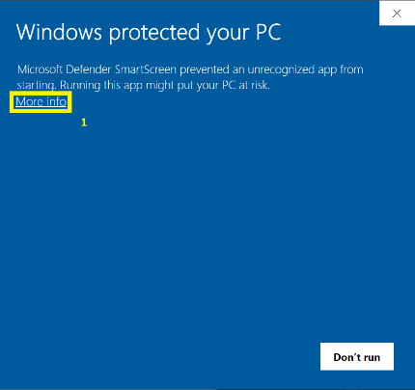 Ein Bild, das Text enthält.

The complete code is available here so in case you think it might be malicious software please check it out:

https://github.com/Chrizzz-1508/Unofficial_Upgrader_for_the_PaF_Extension

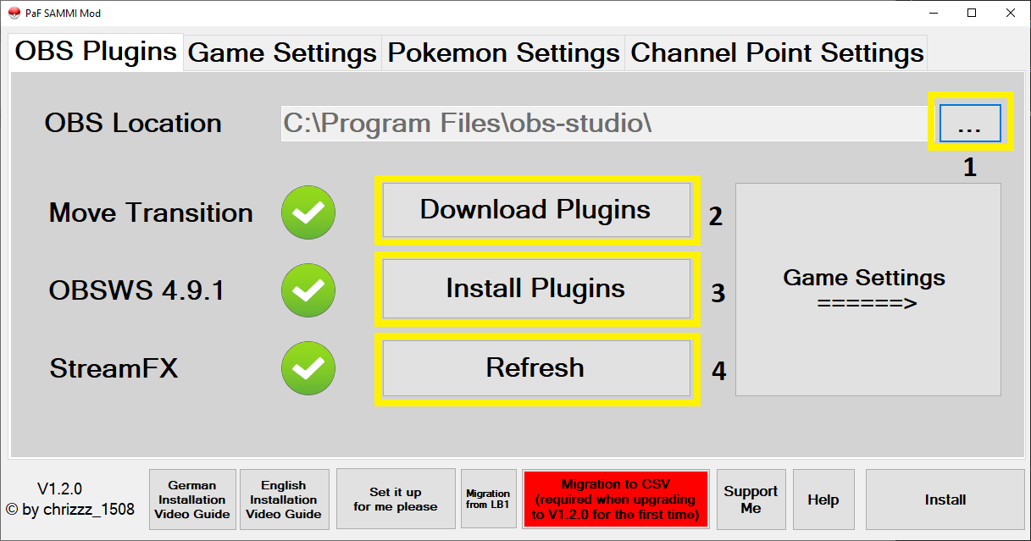

* 1. Select the location of your **OBS32.exe** / **OBS64.exe** (by default it's in: "C:\Program Files\obs-studio\bin\64bit")
  2. Press “***Download Plugins***” and wait until all 3 Plugins are downloaded
  3. Press “***Install Plugins***” and follow the instructions
  4. After installing all 3 Plugins, hit “***Refresh***” to make sure all of them were installed successfully

The Auto Installation only works with OBS V27, if you are using V28+ you will have to install the plugins manually after downloading them.

## **Install / Configure SAMMI**

* 1. Unzip SAMMI to a location where it can stay (you can’t move it easily later without screwing up a lot of things)
  2. Linking your Twitch account and setting the correct scopes

To do this you will have to hit “***Twitch Connections***” 🡺 “***Open URL***”, it’s also recommended to select “***Auto connect to Twitch***”, if you did everything correctly, your account should now show up in SAMMI

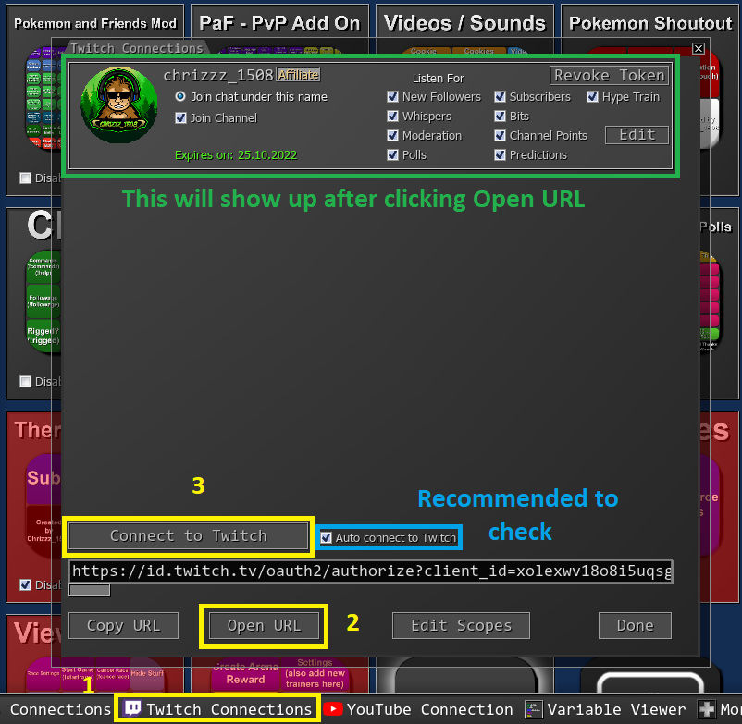

* 1. Adding the SAMMI Bridge to OBS as a Dock

To add the SAMMI Bridge to OBS you first wanna grab the file path of the Bridge. You can get it by going into SAMMI and clicking “***Bridge***” 🡺 “***Copy Full Path***”).

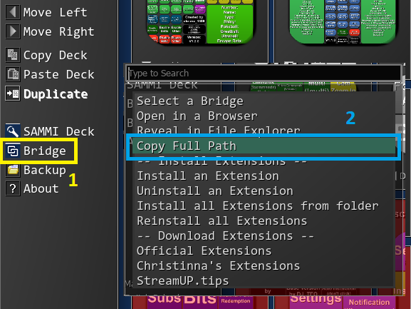

After this, you need to create a new dock in OBS. In OBS go to (“***View***”) 🡺 “***Docks***” 🡺 “***Custom Browser Dock***” and enter any name and paste the file path in the URL field

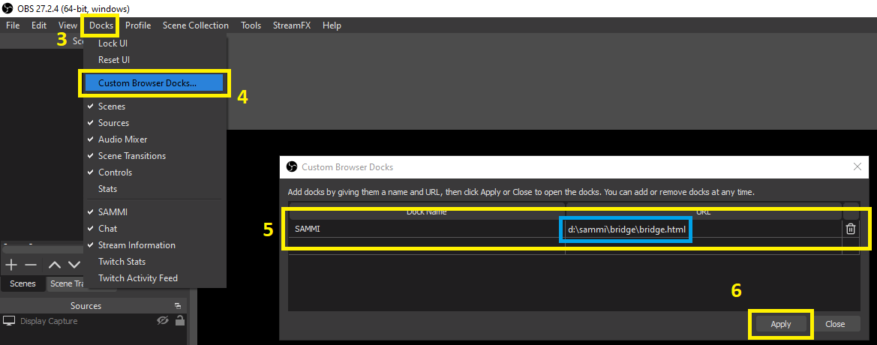

* 1. Connecting SAMMI with OBS

In SAMMI go to “***OBS Settings***” and enter your OBS Websocket Settings.

These can be found in OBS under “***Tools***” 🡺 “***WebSockets Server Settings***”

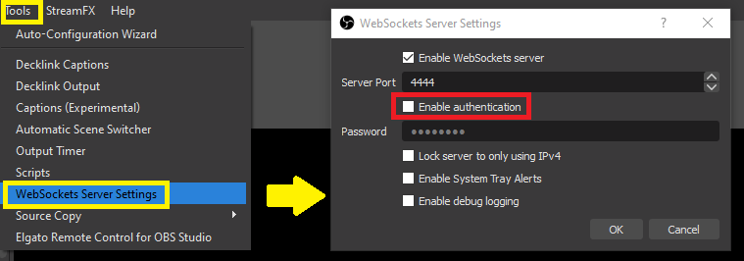

If you have the “***Enable authentication***” box checked, that means you will have a password enabled. If you can’t remember the password, you can either uncheck it or set a new password.

It’s also recommended to untick the “***Enable System Tray Alerts***” box.

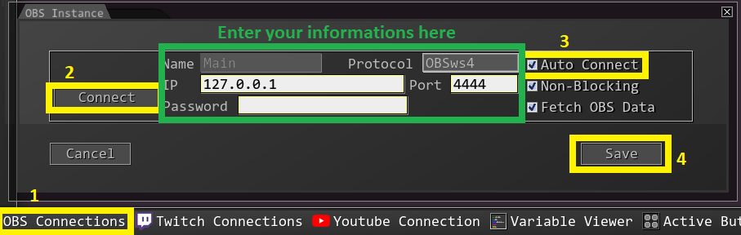

After you have entered your information hit connect (I also recommend checking the “***Auto connect***” box in SAMMI).

* 1. Check if everything is set correctly

If everything was set correctly, the 4 Green Lights on the left side of SAMMI and the 1 Light in the new OBS Dock should be green. If they are not, try restarting OBS and SAMMI and make sure that not multiple instances of SAMMI are open.

Ein Bild, das Text enthält.
Ein Bild, das Text enthält.

## **Install the PaF Game**

* 1. Fill out all fields in “***Game Settings***”, “***Pokemon Settings***” and “***Channel Point Settings***” and then hit “***Install***”

The installer will create a new folder (**Pokemon and Friends**) with all necessary files in your SAMMI Directory. If you are not sure what the settings mean, you can just hover with the mouse over a setting name and a small description will pop up.

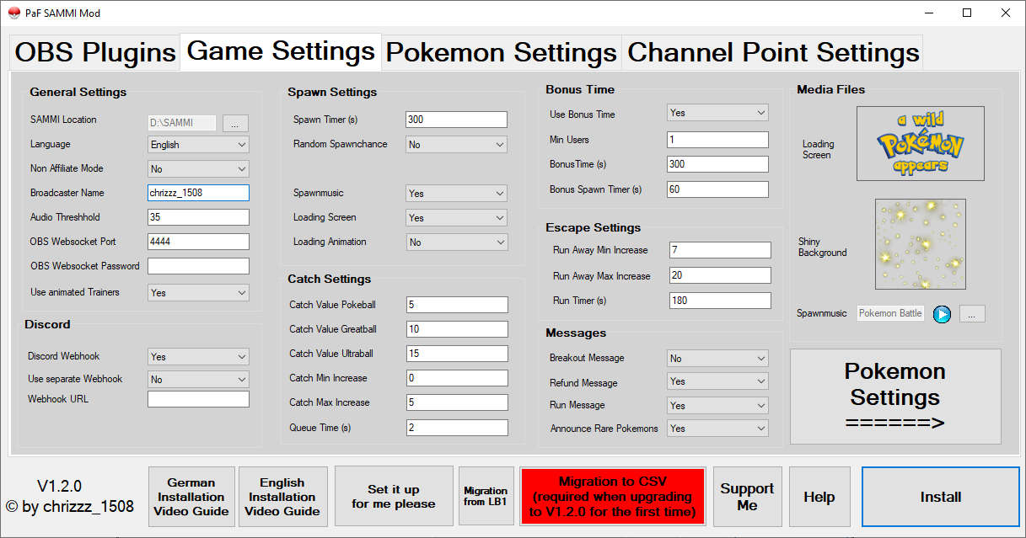

Ein Bild, das Tisch enthält.

Ein Bild, das Tisch enthält.

* 1. Migrate over your process

If you want to carry over the progress of your viewers and the selected trainers from a Version lower than V1.2.0 you will have to hit the “***Migration to CSV***” Button. This button will open a file selector where you will have to select your SAMMI folder.

* 1. Install the PaF Extension

In SAMMI go on “***Bridge***” 🡺 “***Install an Extension***” and select the “***PaFGame.sef***” in your SAMMI 🡺 Pokemon and Friends folder.

This will create a new deck in SAMMI called “**Pokemon and Friends Mod**”.

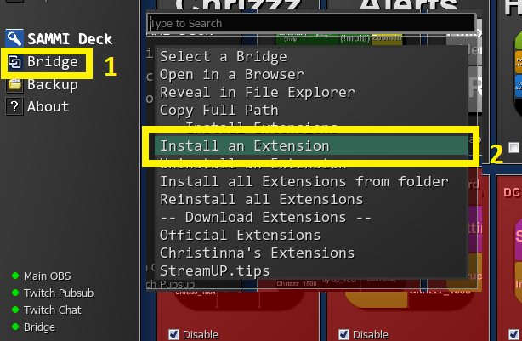

After the extension is installed, the installation process will automatically start.

Don’t touch anything until it will show you the message that the installation is completed. The creation will take around 40-60 seconds and will be confirmed with a message at the end.

In case the Installation fails, you can retrigger it at any time by typing

**!poke-install** into the chat.

* 1. Add the game to your other scenes where you want to use it

To add the game to your existing scenes, just go to these scenes, select “Add source” and then select the “**PaF - Pokemon Scene**”. Feel free to resize it however you want to fit to your scene.

* 1. Adjust the channel point pictures (optional)

Go to your twitch dashboard and change the channel point reward pictures, some sample pictures are included in the installation folder.

# Upgrading from V1.1.6 or lower

1) Delete the old Pokemon Game Channel Point Rewards

2) Delete the old PaF Scenes (this step can be skipped if you are on V1.1.6)

3) Restart OBS

4) Update LB2 to SAMMI V2022.4.1:

1. Download SAMMI from here: https://github.com/SAMMISolutions/SAMMI-Official/releases/tag/2022.4.1
2. Copy the **SAMMI Core.exe**, **data.win** and **DLLExtension.dll** files
3. Paste it into your main folder, clicking yes to overwriting the existing files
4. Run **SAMMI Core.exe** and hit “***Check for Updates***”
5. Update your SAMMI Deck and SAMMI Bridge
6. Change your Transmitter in the OBS Dock to the SAMMI Bridge
7. Remove your Twitch account and readd it

5) Fill out the settings in the mod installer and hit install

6) Use the “***Migration to CSV***” Button to port over your existing data

7) In SAMMI hit “***Bridge***” => “***Install Extension***”

8) Select the **PaFGame.sef** Extension (should be in a folder called Pokemon and Friends in your SAMMI folder)

9) If you are asked for replacing the current files, say yes. Also say yes to recreating the channel points

10) If you are asked to recreate the scene, only recreate them when you deleted them in Step 2, otherwise say no

11) If you recreated the scenes, readd them as nested scenes

12) Change Channel Point pictures (optional)

# Functions

## **Spawn Mechanic**

The Spawn Mechanic has been updated in this version. As long as no Pokémon is currently on the screen, a timer is running in the background. After X amount of time has passed (default 5mins), a new Pokémon is spawned (the spawn can also be bound to a certain chance, so for example after 5min there will be 75% chance).

The viewers can also redeem Channel Point Rewards to immediately spawn a new Pokémon or the broadcaster can summon one with **!poke-start** / **!summon <number / name>** / **!summonshiny <number / name>**.

## **Runaway Mechanic**

For the runaway mechanic there are 2 new changes.

To avoid having a Pokémon stay on screen for too long, there is a timer running (default 3mins) in the background. This timer is reset whenever a ball is thrown. If there is no ball thrown or a “**Give a Gift**” reward is redeemed for the duration of the timer, the Pokémon will run away.

The 2nd change is about the Pokémon running away after it breaks out. In the original game this happens after 3 break outs. For this version a new variable called escape rate is used. Every time a Pokémon breaks out, this escape rate is increased by a random number between 2 values (default 7% and 20%). This value shows the chance of the Pokémon running away after a successful breakout.

The viewers can check the current escape rate with **!escaperate / !er** and use the “**Give a Gift**” Channel Point reward to reduce this chance back to 0%.

## **Catch Mechanic**

The viewers can check the catch rate of the current Pokémon with the **!catchrate** / **!cr** command. This command will show the catch rate for all 3 types of Pokéballs.

If a ball gets thrown, other viewers will have a 2s time window to redeem their balls, they then get queued up and the queue is emptied first before the rewards gets enabled again.

When a viewer tries to catch a Pokémon which they already have, or the Pokémon runs away while there are still balls in the queue, the channel points will be refunded automatically.

## **Broadcaster Commands**

**!poke-install** - Starts the Installation of the modified version (only needed when you are having troubles and it starts not automatically)

**!poke-init** - Resets the game and loads the settings / language keys (needed after changing the settings)

**!poke-start** - Spawn a new Pokémon manually

**!poke-end** - Reset/end the current catch game

**!summon \*** - Summons a specific Pokémon with the entered name / number name

**!summonshiny \*** - Summons a specific Shiny with the entered name / number

**!bonustime** - Starts a bonus time with increased spawn, catch and shiny rate

**!poke-filter / !poke-filter \*** - Filters the Pokémon Spawns to a specific pool like only dragon Pokémons or only legendarys (use **!poke-init** or restart SAMMI to reset this filter)

## **Mod Commands**

**!addpokemon <user> <Pokémon>** - Adds a Pokémon to a specific user

**!addshiny <user> <Pokémon>** - Adds a Shiny to a specific user

**!changename “<userold>” “<usernew>”** - Transfers all data from a username to a new one, needs to be confirmed with **!confirmchange**

## **Viewer Commands**

**!poke-commands** - Shows a list of the available commands

**!pokedex** - Shows information about the current on-screen Pokémon and if the user already caught it  
**!pokedex \*** - Shows information about the Pokémon and if the user already caught it, where **\*** refers to the Pokémon's name or Pokédex number

**!catchrate / !cr** - Shows the catch rate of the current Pokémon with all 3 types of Pokéballs

**!escaperate / !er** - Shows the current runaway chance of the Pokémon

**!top10** / **!top10shiny** / **!top10likeability** - Shows the top 10 leaderboard

**!rank** - Shows the current rank

**!mypokemon** - Sends a list of the users Pokémon to the specified discord channel. You can also use **!mypokemon** fire to filter for a specific type ¹

**!credits** - Shows the creators

**!trainers** - Shows a list of available trainers

**!settrainer \*** - Changes the trainer to a certain sprite for that viewer

**!pet \*** - Pet one of your Pokémons to increase your overall likeability (will affect PvP)

**!sendpokemon <user> <Pokémon>** - Transfers a Pokémon to another user, they will need to accept with either **!accept** or **!decline**

**!sendshiny <user> <Pokémon>** - Transfers a Shiny to another user, they will need to accept with either **!accept** or **!decline**

¹ This command requires the discord webhook to be setup correctly. If you did not setup a discord webhook, you can edit the “***Settings***” button with your webhook information or re-run the installer to setup a webhook.

## **Channel Point Rewards**

**Pokeball** - Throws a Pokeball to try to catch the Pokémon (only available when a Pokémon is on screen)

**Greatball** - Throws a Greatball to try to catch the Pokémon (only available when a Pokémon is on screen)

**Ultraball** - Throws an Ultraball to try to catch the Pokémon (only available when a Pokémon is on screen)

**Masterball** - Throws a Masterball to catch the Pokémon. This ball has a 100% catch rate (only available when a Pokémon is on screen)

**Mystery Pokemon** - Spawns a new random Pokémon (only available when there currently is no Pokémon on screen)

**Mystery Shiny** - Spawns a new random Shiny (only available when there currently is no Pokémon on screen)

**Summon Pokemon** - Spawns a new specific Pokémon (only available when there currently is no Pokémon on screen)

**Give a Gift** - Resets the escape rate of the current Pokémon back to 0% (only available if the escape rate is higher than 0%)

## **Changing Settings**

You can easily change the settings in SAMMI directly by double-clicking the “***Settings***” button in the **Pokemon and Friends Mod** deck.

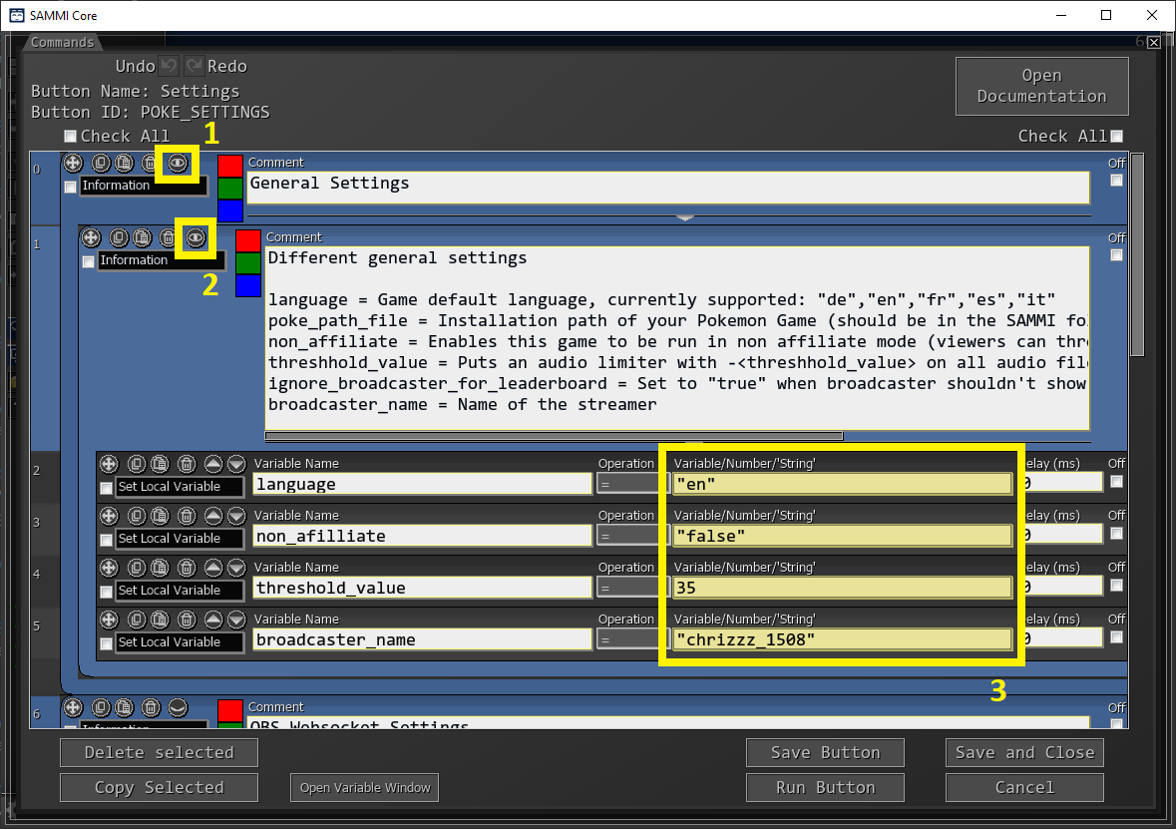

After making any changes to the settings, make sure to type **!poke-init** into your chat to load the new settings.

# Potential Fixes

## **General:**

If something is not working, please check if you have installed the newest Plugins / OBS Version / SAMMI version and if not, please update it first.

## **Discord webhook not working:**

If the Pokémon screenshots are not being posted correctly, please check if you have entered the correct WebSocket Server Settings in the installer.

You can check them in OBS (“***Tools***” 🡺 “***WebSockets Server Settings***”).

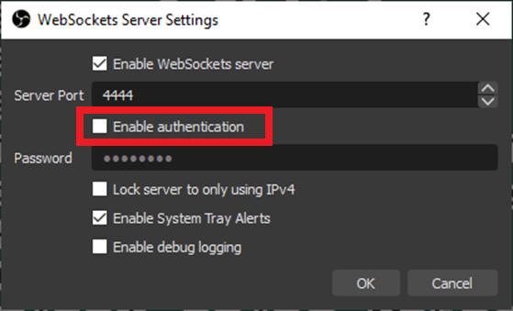

If the “***Enable authentication***” checkbox is checked, you will need to enter the correct password in the upgrader, otherwise just leave the OBS Websocket Password field empty in the upgrader.

Gifs not showing:

A few images won’t have GIFs since they don’t exist yet. In that case it automatically uses a PNG file instead. If I’m able to get these GIFs in the next version, I will swap them out.

## **Profile Pictures not working in the Catch Screenshot / Game keeps crashing on throws**

This means your Twitch Scopes are set incorrectly, please go to the ***SAMMI*** => ***Twitch Settings*** => ***Edit scopes*** => Check the "***View Email adress***" box => hit ***done*** => ***Open URL*** (to gain a new token with the correct scopes)

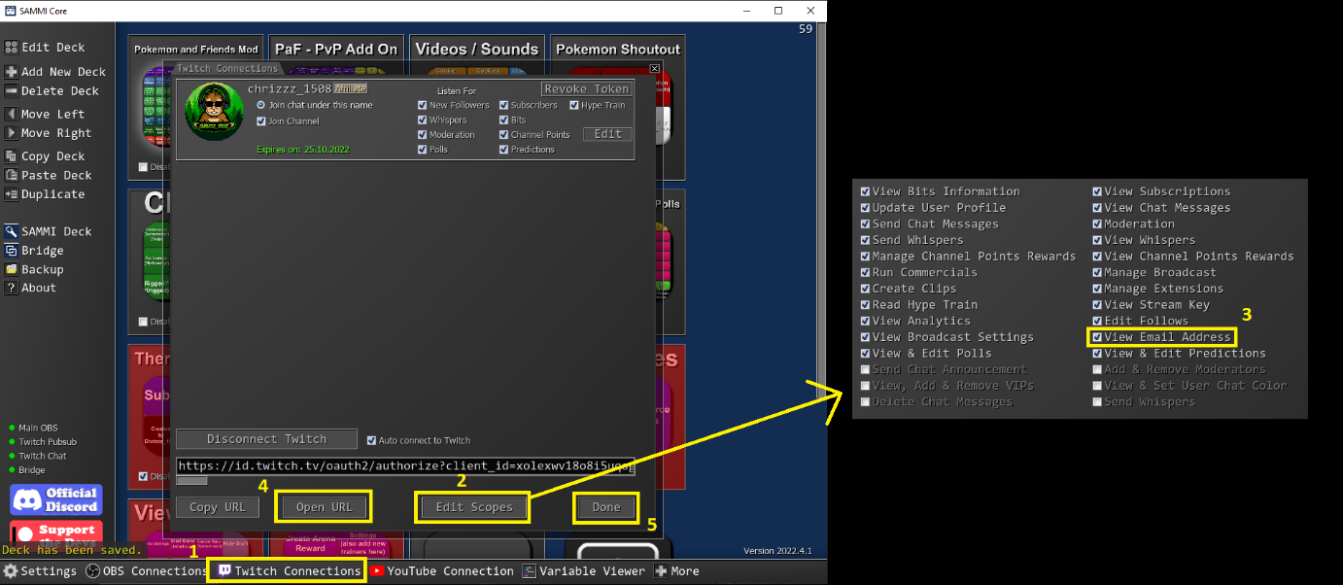

**No Pokémon is appearing:**

This can be because of 2 things:

1) SAMMI and OBS are not connected correctly, please check if all 5 lamps are green and if not refere to the point above on how to fix it

2) The **PaF - Pokemon Scene** and the move transition plugin was not installed correctly (right click the "**PaF - Pokemon Scene**" and check if there are 10 filters) => Please close OBS and reinstall the move transition plugin with the zip file (the normal installer often doesn't work), after that delete the scenes, restart OBS and repeat the progress

# Special Thanks to some awesome People

[**Anni**](https://www.twitch.tv/keenepanik)- The best fiancée I could wish for

[**WaldoAndFriends**](https://www.twitch.tv/waldoandfriends) - Developing of the original Game

[**Silverlink**](https://www.twitch.tv/silverlink)- Allowing me to use parts of the code from OBSCord & The

discord webhook for LB1

**Christinna** - Allowing me to use parts of her Timer extension code

[**SiidNey**](https://www.twitch.tv/siidney)- Creating graphics and helping with a lot of feedback / bugs

[**EveraldJohnson**](https://www.twitch.tv/everaldjohnson)- Resizing all the GIFs and a lot of support

[**ShadowEnigmaTV**](https://www.twitch.tv/shadowenigmatv) - Creating more trainer graphics and the loading animation

[**Pandamonium**](https://www.twitch.tv/misterk_qc/)- French Translation

**DrNicoh** - Spanish Translations

And of course, all the awesome beta testers!

**Credits:**

The graphics are being based on the graphics of the following sites / users:

- FurretTurret

- pkparaiso.com

- eternia.fr

- bisafans.de

# Final notes

If any problems occur during the installation, please make sure that you've followed all steps correctly and all prerequisites were installed / updated accordingly.

If the problem still persists you can get support on

[**my Discord Server (https:/discord.com/invite/A3VF9kW)**](https://discord.com/invite/A3VF9kW)or on the

**Streamup Discord (**[**https://discord.com/invite/RnDKRaVCEu**](https://discord.com/invite/RnDKRaVCEu)**)**

in the pokemon-and-friends-mod channel.

Thanks for downloading!



# Support me

Hey everyone,

my name is Chrizzz and I'm a C# developer that loves to create fun stuff.

This content is completely free. But if you feel like you want to leave me a tip, I would really appreciate it!

You can tip me via PayPal here:

[](https://www.paypal.com/paypalme/chrizzz1508)

<https://www.paypal.com/paypalme/chrizzz1508>

I'm also a streamer on Twitch! Please feel free to also drop by in my stream over at twitch and hang out with me.

[](https://twitch.tv/chrizzz_1508)

<https://twitch.tv/chrizzz_1508>

I would love to meet you!

Thank you for using this modified version of Pokémon and Friends!

I truly hope you love it!